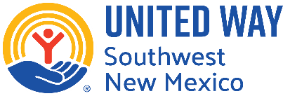

UNITED WAY OF SOUTHWEST NEW MEXICO

Community Impact Fund Process
Funding Year 2026/2027

DONA ANA COUNTY
GRANT COUNTY
LUNA COUNTY

Deadline for Submitting Application:

Thursday, April 16, 2026 by 5 p.m. via www.uwswnm.org/CIF2026

CONTENTS

INTRODUCTION
About United Way of Southwest New Mexico............................................................... Page 3
About the Community Impact Fund............................................................................. Page 4

APPLYING FOR A COMMUNITY IMPACT FUND GRANT
United Way Impact Areas................................................................................ Page 4
Eligibility Requirements – Request Level........................................................... Page 4-5
PHASE I: Application Evaluation....................................................................... Page 5
GRANT PROCESS AND TIMELINE AND KEY DATES............................................... Page 6

Annual Program Grant Process Timeline
Phase 1: Grant Application | Week of March 9, 2026 | Grant application available
 | April 16, 2026, 5:00 pm | Due Date: Completed Grants application  (late submissions are not accepted)
Phase 2: Panel Presentations | May 7, 2026-Grant County  May 14, 2026-Dona Ana County  TBD-Luna County  **Subject to change** | Grant Review Panels convene for agency presentations (All qualifying programs will be emailed regarding presentation times) Grant Review Panels score applications and recommend grantees.
Phase 3: Allocations | Week of May 18-22, 2026 | UWSWNM Board reviews and approves amounts
 | Week of June 1, 2026 | Award agreements are emailed via Adobe acrobat
 | June 18, 2026 | All agreements DUE
 | July 1, 2026 | 1st payment issued
 | January 28, 2027 | Due Date: Mid-Year Report/2nd payment issued
 | July 29, 2027 | Due Date: Year-End Report

INTRODUCTION

ABOUT UNITED WAY OF SOUTHWEST NEW MEXICO
United Way of Southwest New Mexico (UWSWNM) seeks to improve the quality of life within our southwest region of New Mexico, by showing measurable and sustainable progress on our community goals in the Impact Areas of Healthy Community, Youth Opportunity, Financial Security, Community Resiliency.
Our Vision To achieve a stronger community by uniting our collective power to create positive, meaningful change.
Our Mission To improve lives by mobilizing the caring power of our community to advance the common good.

Our Impact Areas
The United Way of Southwest New Mexico works towards strengthening local resilience to advancing health, youth opportunity, and financial security, United Way is mobilizing communities to action so all can thrive.

Healthy Community  Improving health and wellbeing for all  Associated initiative examples:  - Health Care access  - Maternal and child health  - Nutrition and food security  - Chronic and infectious disease awareness and prevention  - Mental health support  - Substance misuse recovery and prevention | Youth Opportunity  Helping young people realize their full potential  Associated initiative examples:  - Childcare and early childhood education  - In-school, after-school and summer learning  - Family engagement  - Literacy development  - College and career readiness
Financial Security  Creating a stronger financial future for every generation  Associated initiative examples:  - Adult education, job training, and career pathways  - Financial education and coaching  - Homelessness prevention, affordable housing, and homeownership  - Small business support  - Public benefits access | Community Resiliency  Addressing urgent needs today for a better tomorrow  Associated initiative examples:  - Crisis hotline and support  - Emergency preparedness  - Disaster relief and recovery  - Environmental stewardship and sustainability

ABOUT THE COMMUNITY IMPACT FUND

The Community Impact Fund is one of the ways that UWSWNM makes strategic investments to drive measurable, sustainable change in Basic Needs, Education and Financial Stability in our region.

The Community Impact Fund is composed of contributions from donors who entrust UWSWNM with combining their gifts with the donations of others to invest in dynamic approaches and proven services to create lasting, positive change. The process of investing includes an informed review by dedicated volunteers who help us ensure the most positive impact with the dollars raised.
Please note: The actual dollars invested during the 2026-2027 Community Impact Fund are contingent upon our 2025 campaign results.

APPLYING FOR A COMMUNITY IMPACT FUND GRANT

ELIGIBILITY REQUIREMENTS – ORGANIZATION LEVEL
To be eligible to apply and receive funding through the Community Impact Fund Grant Process, an Organization must meet all the following criteria:
- Be recognized as an organization exempt from federal income tax under I.R.S. Section 501(c)(3) of the Internal Revenue Code 1986.
- Be primarily involved in providing and services that are healthy community, youth opportunity, financial security or community resiliency and directly service one or more of the UWSWNM region service area residents (Dona Ana, Grant, Luna).
- Have an independent governing body of voting members who are resident volunteers. This governing body has the authority to decide policy and strategic direction with respect to the organization’s programs, administration and finances, in accordance with the organization’s By-laws, and who shall meet at least four times per year. Paid staff must not be a voting member of the Board.
- Maintain a non-discrimination policy or plan that does not discriminate on the basis of race, cultural heritage, religion, gender, national origin, age, marital status, sexual orientation, veteran status or status as a qualified disabled or handicapped individual.

Have an annual audit or financial review performed by a certified accountant that is licensed and in good standing with the State of New Mexico.
- Meet the funding expectations and requirement for the Impact Area and strategies under which the request is made.
- Working on collaboration with similar services to ensure maximum outreach or have an implementation plan for collaboration.

COMMUNITY IMPACT FUND APPLICATION RUBRIC
The application rubric is to help assess the submitted application in a more specific manner. The UWSWNM staff will conduct an initial review of the application, based on the rubric, to ensure the application was submitted correctly. Any applications submitted will be thoroughly reviewed by the UWSWNM staff. If there are any errors, UWSWNM will contact the Organization with suggestions to correct the application. An example of the rubric used to review applications can be found on the CIF Landing page- uswswnm.org/cif2026

APPLICATION EVALUATION
Once a request application has been submitted, it enters the review, assessment and decision-making phase. An overview of this phase is shown below, and the components are described in more detail on the following pages.
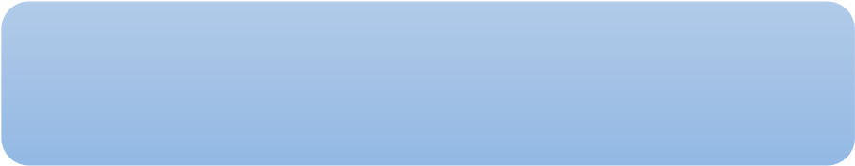
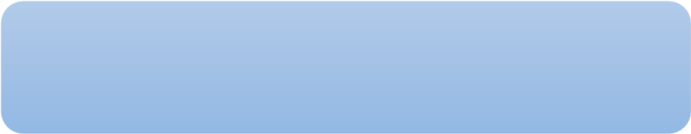
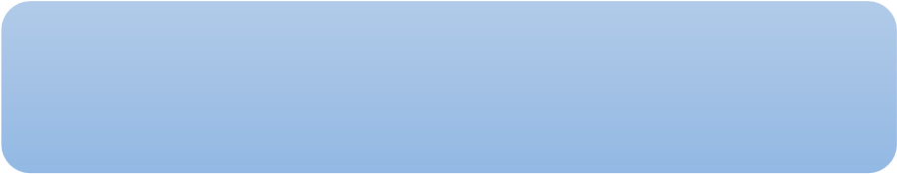



Application Compliance Review

Volunteer Assessment Review

Volunteer Recommendations
and Approval

UWSWNM staff will review to ensure the program application is on time and complete with required attachments.

Community Investment Volunteers review applications and observe agency presentations to address concerns or ask additional questions.

Community Investment Volunteers make funding recommendations that will be presented to the UWSWNM Board of Directors for approval.

Community Investment Committee Application Review
All applications will be reviewed individually by the Community Investment Committee, which is comprised of community members and donors. The committee will provide expertise and feedback to ensure the most positive funding recommendation is made.

Decision Making & Funding Communications

Funding Approval
The recommendations of the Community Investment Committee will be reviewed and ratified and then approved by the UWSWNM Board of Directors.
Upon the final decision by the UWSWNM Board, each Organization will be notified of that decision. Agencies with requests approved for funding by the UWSWNM Board, will be notified via email with the amount of their UWSWNM Community Impact Fund grant along with the funding agreement.

Important Notes Regarding Changes in Reported Information:
- If reported information changes during the Community Impact Fund Grant Process (after submission of the application but before funding has been awarded), the Organization must submit written notification to UWSWNM immediately after the Organization becomes aware of the change.
- If reported information changes after the application has been funded (after the grant has been awarded and the Organization has started to receive funding), the Organization must submit a written notification to UWSWNM within 30 days after the Organization becomes aware of the change.

Following Funding Approval
- Upon receiving notification of the UWSWNM grant, the organization will complete a grant agreement. The funding agreement will be sent to CEO and Program Manager for electronic signature via Adobe sign.

GRANT PROCESS TIMELINE AND KEY DATES

Community Impact Funding Application Release for Dona Ana, Grant, and Luna Counties.

APPLICATION SUBMISSION DEADLINE
- Request applications must be submitted online on Thursday April 16, 2026, by 5pm at www.uwswnm.org/CIF2026 to be considered for funding.

COMMUNITY INVESTMENT COMMITTEE
The volunteer committee will meet to review applications and discussion funding recommendations. If necessary, we will ask your organization to present or provide additional information for the committee.
- Dona Ana County- Thursday, May 14, 2026
- Grant County- Thursday, May 7, 2026
- Luna County-TBD
*These dates are subject to change.

FUNDING APPROVAL
• Funding recommendations are approved by the UWSWNM Community Investment Committee with the United Way Board of Directors giving final approval.
• Award notification will be sent by no later than week of June 1, 2026.
If awarded, the Funding Agreement will be sent via email FROM ADOBE SIGN with the award notification. The Funding Agreement will be due by June 18, 2026. Signatures of required parties is mandatory for validity.

FUNDING PERIOD: July 1, 2026 – June 30, 2027

*Please keep updated with the United Way of Southwest New Mexico to make sure the timeline is still up to date. Notification will also be sent out to contacts identified in the application.
For any questions, please contact Gabe Holguin at gabriel@uwswnm.org or 575.524.7561.

Thank you!

