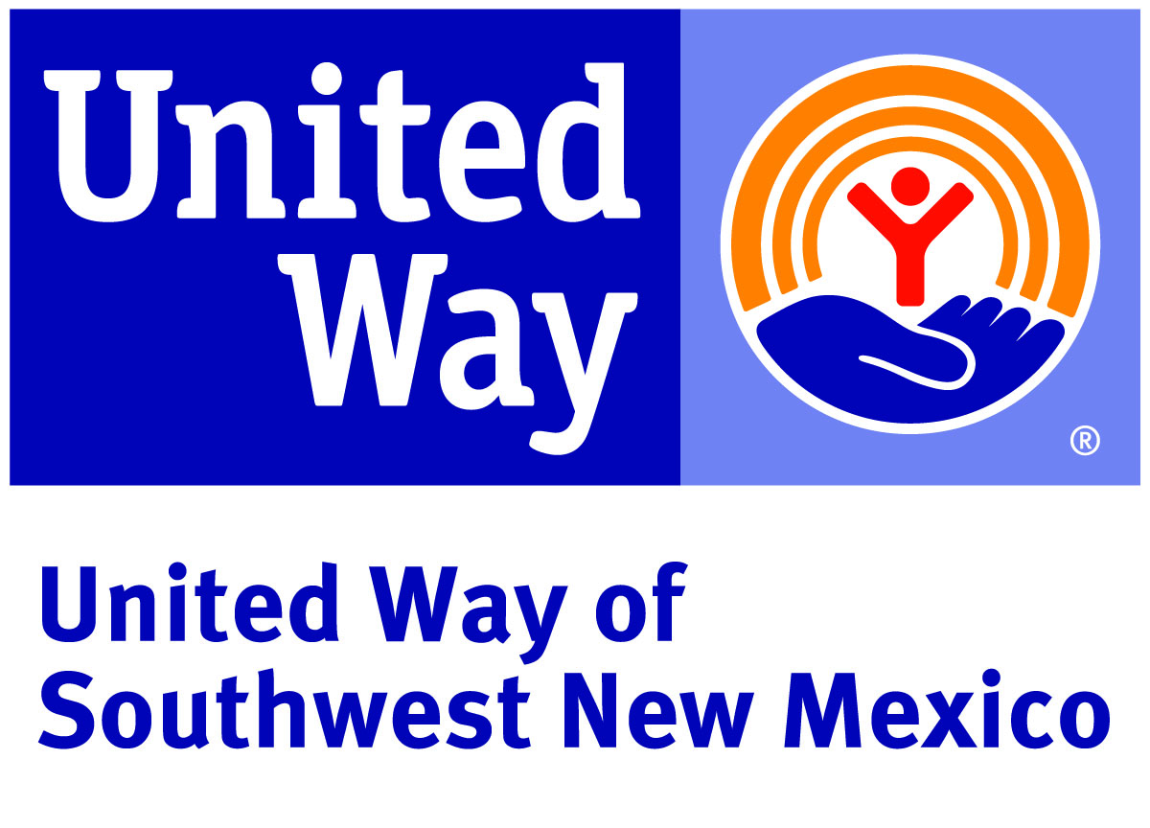

UNITED WAY OF SOUTHWEST NEW MEXICO

Community Impact Fund Grant
Funding Year 2024/2025

DONA ANA COUNTY
GRANT COUNTY
LUNA COUNTY

Deadline for Submitting Application:

Friday, April 26, 2024 by 5 p.m. via www.uwswnm.org/CIF2024

CONTENTS

INTRODUCTION
About United Way of Southwest New Mexico............................................................... Page 3
About the Community Impact Fund............................................................................. Page 4

APPLYING FOR A COMMUNITY IMPACT FUND GRANT
United Way Focus Areas.................................................................................. Page 5
Eligibility Requirements – Request Level........................................................... Page 6
PHASE I: Application Evaluation....................................................................... Page 7
GRANT PROCESS AND TIMELINE AND KEY DATES............................................... Page 8

Annual Program Grant Process Timeline
Phase 1: Grant Application | March 18, 2024 | Grant application available
 | April 26, 2024 5:00 pm | Due Date: Completed Grants application  (late submissions are not accepted)
Phase 2: Panel Presentations | May 10, 2024-Grant County  May 14, 2024-Dona Ana County  TBD-Luna County | Grant Review Panels convene for agency presentations (All qualifying programs will be emailed regarding presentation times) Grant Review Panels score applications and recommend grantees.
Phase 3: Allocations | Week of May 20-24, 2024 | UWSNM Board reviews and approves amounts
 | June 3, 2024 | Award agreements are emailed via Adobe acrobat
 | June 21, 2024 | All agreements DUE
 | July 1, 2024 | 1st payment issued
 | January 31, 2025 | Due Date: Mid-Year Report/2nd payment issued
 | July 31, 2025 | Due Date: Year-End Report

INTRODUCTION

ABOUT UNITED WAY OF SOUTHWEST NEW MEXICO
United Way of Southwest New Mexico (UWSWNM) seeks to improve the quality of life within our southwest region of New Mexico, by showing measurable and sustainable progress on our community goals in the Focus Areas of Basic Needs, Education and Financial Stability.
Our Vision To achieve a stronger community by uniting our collective power to create positive, meaningful change.
Our Mission To improve lives by mobilizing the caring power of our community to advance the common good.

Our Focus Areas
The United Way of Southwest New Mexico works to provide the most effective venue for giving and effecting change in our community, consolidating our collective resources for a targeted approach to improve lives by focusing on supporting services that address the very building blocks for a good life.

Financial
Stability

Education
Basic Needs

We do this through Community Impact.

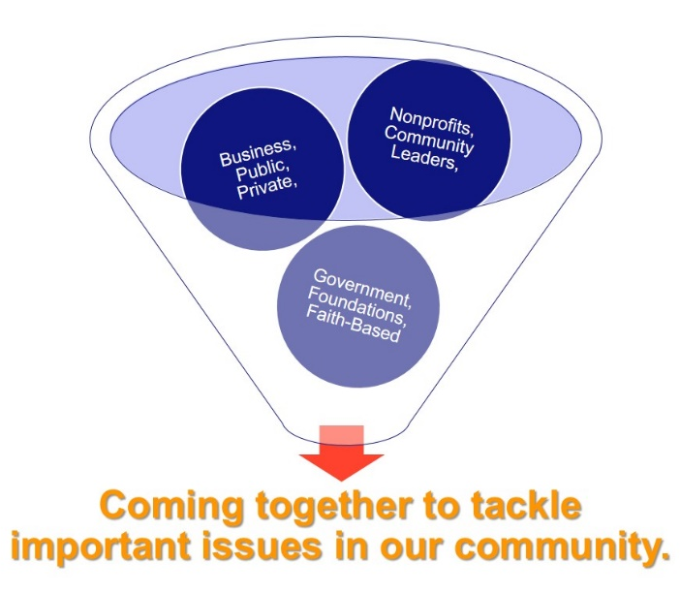

Achieving our Community Impact Initiatives will require a variety of tactics including research, building collaborative community partnerships, funding, volunteerism and advocacy in the Focus Areas.

ABOUT THE COMMUNITY IMPACT FUND

The Community Impact Fund is one of the ways that UWSWNM makes strategic investments to drive measurable, sustainable change in Basic Needs, Education and Financial Stability in our region.

The Community Impact Fund is composed of contributions from donors who entrust UWSWNM with combining their gifts with the donations of others to invest in dynamic approaches and proven services to create lasting, positive change. The process of investing includes an informed review by dedicated volunteers who help us ensure the most positive impact with the dollars raised.
Please note: The actual dollars invested during the 2024-2025 Community Impact Fund are contingent upon our 2023 campaign results.

United Way of Southwest New Mexico is taking a more focused approach with Community Impact Fund for Dona Ana, Grant, and Luna Counties, striving to make an impact in the following areas:

Basic Needs Focus Areas
Problem Statement:
Evidence suggests that the lack of opportunities that are associated with poverty and low socio-economic status may have particularly long-lasting and powerful effects on children that can last into adulthood. Childhood poverty is linked to a variety of health, cognitive, and emotional risk factors. They are less likely to have access to fresh, healthy food, adequate housing, and community resources like great schools and safe places to play. As a direct result, they have fewer opportunities to help them thrive, succeed, and achieve their full potential.

United Way Southwest NM Impact Goal:
To improve the quality of life for low- income children and families by linking them to vital community resources and services.

Education Focus Areas
Problem Statement:
School-aged children living in poverty face unique challenges that reduce their quality of education. Reading proficiency is a crucial element of scholastic success.
Children need to be able to read proficiently by fourth grade in order to be able to use their reading skills to learn other school subjects. Children who cannot read proficiently will fall further and further behind as reading-based curricula move increasingly out of their reach. In fact, kids who are not reading at grade level by this critical point are more likely to drop out of school and less likely to go to college.

United Way Southwest NM Impact Goal:
To decrease barriers to educational success for children living in low-income neighborhoods by improving the quality of and access to supplemental supports.

Financial Stability Priorities
Problem Statement:
While most other states have recovered from the recession, New Mexico’s economic recovery has flat-lined. Just as our state cannot thrive when so many of our families are struggling economically, children cannot thrive when they face stressors and adverse experiences that negatively affect their brain development, long-term health, and socio-emotional well-being. Research shows that a child’s well-being is strongly tied to his or her family’s stability and resources, and so in addition to championing policies that are best for New Mexico’s kids, policy-makers should also promote strategies that increase the strength of New Mexico parents and families. Any programs that seek to improve child outcomes should be coordinated with services that address the needs of parents. What’s known as a “two-generation approach” is critical.

United Way Southwest NM Impact Goal:
To increase the number of opportunities for low-income individuals and families to become economically self-sufficient.

APPLYING FOR A COMMUNITY IMPACT FUND GRANT

ELIGIBILITY REQUIREMENTS – ORGANIZATION LEVEL
To be eligible to apply and receive funding through the Community Impact Fund Grant Process, an Organization must meet all the following criteria:
- Be recognized as an organization exempt from federal income tax under I.R.S. Section 501(c)(3) of the Internal Revenue Code 1986.
- Be primarily involved in providing and services that are health, education or human-service related and directly service one or more of the UWSWNM region service area residents (Dona Ana, Grant, Luna).
- Have an independent governing body of voting members who are resident volunteers. This governing body has the authority to decide policy and strategic direction with respect to the organization’s programs, administration and finances, in accordance with the organization’s By-laws, and who shall meet at least four times per year. Paid staff must not be a voting member of the Board.
- Maintain a non-discrimination policy or plan that does not discriminate on the basis of race, cultural heritage, religion, gender, national origin, age, marital status, sexual orientation, veteran status or status as a qualified disabled or handicapped individual.

Have an annual audit or financial review performed by a certified accountant that is licensed and in good standing with the State of New Mexico.
- Meet the funding expectations and requirement for the Focus Area and strategies under which the request is made.
- Working on collaboration with similar services to ensure maximum outreach or have an implementation plan for collaboration.

COMMUNITY IMPACT FUND APPLICATION RUBRIC
The application rubric is to help assess the submitted application in a more specific manner. The UWSWNM staff will conduct an initial review of the application, based on the rubric, to ensure the application was submitted correctly. Any applications submitted will be thoroughly reviewed by the UWSWNM staff. If there are any errors, UWSWNM will contact the Organization with suggestions to correct the application. An example of the rubric used to review applications can be found on the CIF Landing page- uswswnm.org/cif2024

APPLICATION EVALUATION
Each phase of the process is screened by UWSWNM volunteers. Once a request application has been submitted, it enters the review, assessment and decision-making phase. An overview of this phase is shown below, and the components are described in more detail on the following pages.

Application Compliance Review

Volunteer Application Review

Volunteer Recommendations
and Approval

UWSWNM staff review application to ensure they are on time
and complete.

Community Investment Volunteers review and discuss applications and address any concerns.

Community Investment Volunteers make funding recommendations that will be presented to the UWSWNM Board of Directors for approval.

Community Investment Committee Application Review
All applications will be reviewed individually by the Community Investment Committee, which is comprised of caring community members. The committee will provide expertise and great feedback to ensure the most positive funding recommendation is made.

Decision Making & Funding Communications

Funding Approval
The recommendations of the Community Investment Committee will be reviewed and ratified and then approved by the UWSWNM Board of Directors.
Upon the final decision by the UWSWNM Board, each Organization will be notified of that decision. Agencies with requests approved for funding by the UWSWNM Board, will be mailed a letter with the amount of their UWSWNM Community Impact Fund grant along with the funding agreement.

Important Notes Regarding Changes in Reported Information:
- If reported information changes during the Community Impact Fund Grant Process (after submission of the application but before funding has been awarded), the Organization must submit written notification to UWSWNM immediately after the Organization becomes aware of the change.
- If reported information changes after the application has been funded (after the grant has been awarded and the Organization has started to receive funding), the Organization must submit a written notification to UWSWNM within 30 days after the Organization becomes aware of the change.

Following Funding Approval
- Upon receiving notification of the UWSWNM grant, the organization will complete a grant agreement.

GRANT PROCESS TIMELINE AND KEY DATES

Community Impact Funding Application Release for Dona Ana, Grant, and Luna Counties.

APPLICATION SUBMISSION DEADLINE
- Request applications must be submitted online on Friday April 26, 2024, by 5pm at www.uwswnm.org/CIF2024 to be considered for funding.

COMMUNITY INVESTMENT COMMITTEE
The volunteer committee will meet to review applications and discussion funding recommendations. If necessary, we will ask your organization to present or provide additional information for the committee.
- Dona Ana County- Wednesday, May 15, 2024
- Grant County- Friday, May 10, 2024
- Luna County-TBD
*These dates are subject to change.

FUNDING APPROVAL
• Funding recommendations are approved by the UWSWNM Community Investment Committee with the United Way Board of Directors giving final approval.
• Award notification will be sent by no later than June 3, 2024.
If awarded, the Funding Agreement will be sent via email with the award notification. The Funding Agreement will be due by June 21, 2024. Signatures of required parties is mandatory for validity.

FUNDING PERIOD: July 1, 2024 – June 30, 2025

*Please keep updated with the United Way of Southwest New Mexico to make sure the timeline is still up to date. Notification will also be sent out to contacts identified in the application.
For any questions, please contact Monica Whitman at monicaw@uwswnm.org or 575.524.7561.

Thank you!

