Community Impact Fund FAQs
The following is a list of frequently asked questions (FAQs) regarding United Way of Southwest New Mexico’s 2022-2023 grant cycle.

Q. Is this application open to any non-profit organization?
UWSWNM welcomes applications from any human-services related 501(c)3 organization who fall within the focus areas that United Way SWNM has provided.
Q. Are for-profit organizations eligible to apply for UWSWNM funding?
While for-profit organizations can be noted as partners in the application, UWSWNM will only fund non-profit organizations.
Q. How does organizational size affect ability to compete?
It doesn’t. Organizational size is not a factor in evaluating applicants. Funding decisions are based on alignment with United Way SWNM’s priorities and ability to demonstrate tangible, measurable results.
Q. Can a nonprofit organization apply for more than one category of funding?
Organizations can only submit one application per County they serve.
Q. Is collaboration a requirement or a suggestion?
UWSWNM asks that organizations identify current and potential partners, in addition to noting why that partnership will help better serve the population they reach. These will be scored according to the scoring guidelines. UWSWNM will also offer professional development and capacity building opportunities to grantees and occasional workshops on collaboration to the nonprofit sector.
Q. Should I still apply if we have not been previously funded or currently funded by United Way SWNM?
Yes. Current grantees or organizations that received funding in prior years are not given special consideration by the grant review committee.

Q. Can I get feedback about our previous year’s grant application?
Yes, if at any time your organization would like to ask follow up questions regarding the application that was submitted, please reach out to the United Way of SWNM grant representative that has been identified.

Q. Who reviews the final grant applications?
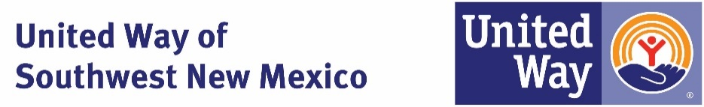
The application process is overseen by a Community Investment Committee. The Committee is comprised of a diverse group of highly-engaged external professionals that include board, corporate and donors from across the region who volunteer their time to review grant submissions. These external reviewers are selected from academia and the public and private sectors based upon their experience and extensive knowledge in their field.

