*Applicant agency must be nonprofit or a government agency that has provided COVID-19 related food and/or shelter services*
EFSP Funding are Federal funds made available through the U.S. Department of Homeland Security’s Federal Emergency Management Agency

Submit a copy of the entire original application with required attachments.
Mail to United Way at PO Box 1347, Las Cruces, NM 88004 OR email to Amanda Morales, EFSP Local Board Chair, impact@uwswnm.org

I. Agency Information:
Your Organization’s Legal Name
Address (Street/P.O. Box)
City, State, ZIP
Telephone / FAX | Phone: | Fax:
Email Address
Website Address
Type of Business
Length of Time in Business
Number of FT Employees
Number of PT Employees
Number of Volunteers
Federal ID Number (required for funding)
NM Tax ID #
DUNS# (required for funding)
Filing Status, i.e. 501(C)(3)

II. Management/Signatory Contact Information

Primary Contact Name / Title
Email Address / Phone | Email: | Phone:
Secondary Contact Name / Title
Email Address / Phone | Email: | Phone:
Agency Telephone / FAX | Phone: | Fax:

III. Summary of EFSP Funding Requested by Program Area:

Program Area | Total Amount Requested | Projected Service Level(s) |  | Estimate Unit/Per Diem Cost
A – Served Meals  May claim $2.00 per meal | $ | Estimated # of Meals: | Estimated # of People Served:
B – Other Food (pantry) | $ | Estimated # of Meals: | Estimated # of People Served:
C – Mass Shelter  $7.50 per shelter night | $ | Estimated # Nights: | Estimated # of People Served:
D – Rent/Mortgage | $ | Estimated # Bills paid: | Estimated # of People Served:
E – Other Shelter (Motel Vouchers) | $ | Estimated # Nights: | Estimated # of People Served:
F – Utility Assistance | $ | Estimated # Bills paid: | Estimated # of People Served:
G – Supplies & Equipment | $ | NTE $300, See limitations in EFSP manual |  | N/A
H – Administration | $ N/A | Local Board Use Only Limited to 2% |  | N/A
Total Request: | $

IV. Financial and Program Information
EFSP funding is designed to supplement existing programs. Below, please provide overall Financial Information for each of the Program Areas for which you are requesting supplemental EFSP funding. Use the Program Area(s) specified above in “III. Summary of EFSP Funding Requested by Program Area”, i.e. “B – Other Food (pantry)” to provide agency information for each Program Area for which you are requesting EFSP funding:

#1 - Program Area Description (i.e. B – Other Food):
Provide financial information below specific to the Program Area, only
Total Previous FY Funding | $ | Previous FY Total Program Expenditures | $
Previous FY EFSP Funding | $ | Projected Program Budget this FY | $
Previous FY - all other Funding | $ | Projected other (non-EFSP) Funding this FY | $
Previous FY Service Level (i.e. # meals, individuals or families served):
NARRATIVE: Provide a Brief Narrative of COVID-19 Related Services:

STATEMENT OF NEED - Why is this service needed in Dona Ana County?

TARGET POPULATIONS: Describe the target Populations to receive these services; (i.e. Seniors, Children, Veterans, etc.)

SERVICE DELIVERY: Where will these services be provided? (Agencies are strongly encouraged to deliver at least 25% of services outside of the Las Cruces City limits)

COLLABORATION: What other agencies provide these services in Dona Ana County and how does your agency collaborate with them to maximize services and reduce duplication?

PAST PERFORMANCE: Describe how your agency defined and achieved goals and objectives in the previous fiscal year.

#2 - Program Area Description (i.e. B – Mortgage Rent, Utilities):
Provide financial information below specific to the above Program Area, only
Total Previous FY Funding | $ | Previous FY Total Program Expenditures | $
Previous FY EFSP Funding | $ | Projected Program Budget this FY | $
Previous FY - all other Funding | $ | Projected other (non-EFSP) Funding this FY | $
Previous FY Service Level (i.e. # meals, individuals or families served):
NARRATIVE: Provide a Brief Narrative of COVID-19 Related Services :

STATEMENT OF NEED - Why is this service needed in Dona Ana County?

TARGET POPULATIONS: Describe the target Populations to receive these services; (i.e. Seniors, Children, Veterans, etc.)

SERVICE DELIVERY: Where will these services be provided? (Agencies are strongly encouraged to deliver at least 25% of services outside of the Las Cruces City limits)

COLLABORATION: What other agencies provide these services in Dona Ana County and How does your agency collaborate with them to maximize services and reduce duplication?

PAST PERFORMANCE: Describe how your agency defined and achieved goals and objectives in the previous fiscal year.

#3 - Program Area Description (i.e. B – Mass Shelter):
Provide financial information below specific to the above Program Area, only
Total Previous FY Funding | $ | Previous FY Total Program Expenditures | $
Previous FY EFSP Funding | $ | Projected Program Budget this FY | $
Previous FY - all other Funding | $ | Projected other (non-EFSP) Funding this FY | $
Previous FY Service Level (i.e. # meals, individuals or families served):
NARRATIVE: Provide a Brief Narrative of COVID-19 Related Services :

STATEMENT OF NEED - Why is this service needed in Dona Ana County?

TARGET POPULATIONS: Describe the target Populations to receive these services; (i.e. Seniors, Children, Veterans, etc.)

SERVICE DELIVERY: Where will these services be provided? (Agencies are strongly encouraged to deliver at least 25% of services outside of the Las Cruces City limits)

COLLABORATION: What other agencies provide these services in Dona Ana County and How does your agency collaborate with them to maximize services and reduce duplication?

PAST PERFORMANCE: Describe how your agency defined and achieved goals and objectives in the previous fiscal year.

V: Previous EFSP Experience Details

- Did your LRO return any unexpended funds last phase? ________ If Yes, please explain.

- Did your LRO have documentation compliance exceptions during any phase that you received funding? _______ If Yes,

Please explain in detail dates and phase in which the exception occurred.

- Was your organization awarded fund last year? If Yes, please list the program area(s) and amount(s).

____________________________________________________________________________________________________________

VI. Other Agency Information (required):

Local Recipient Organization (LRO) Number _________________________ (Leave blank if new)

If the amounts requested are more or less than the amount you received for previous year, please explain / justify:
___________

___________

If your agency receives more than $25,000 in EFSP funds, please provide a copy of your most recent audit.
Your agency must have Electronic Funds Transfer to be eligible for funding.

Are you enrolled for Electronic Funds Transfer? ___Yes ___No, if NO, your agency will need to be enrolled before the application is submitted for consideration.

VII. Required Attachments:

All of the following attachments must be included with your proposal. Please organize and label each attachment with the corresponding alphabetical indicator below:

☐ Copy of Agency 501 (c) (3) documentation | ☐ Detailed Budget for each EFSP area of funding
☐ Copy of most recent audit | ☐ Federal DUNS Number documentation
☐ Copy of Organization total operating budget

Some documents are required in addition to this application for official submission to the National EFSP Board. IF your organization receives funding, please ensure the bolded forms below are completed.

☐ Local Recipient Organization Certification (Completed via Docusign)
☐ Certification Regarding Lobbying (Completed via Docusign) **only for LRO’s that receive $100,000 or more from EFSP**
☐ Fiscal Agency Relationship Certification (if applicable)

VIII. Certifications:
I certify that this proposal and all supporting documentation provided are true and accurate statements, that I have declared all of the sources of funds for these requested services, and that clients / services reported are unduplicated. I further certify that I am a fully authorized signatory for the Agency submitting this proposal and/or its Board of Directors (two signatures) required:

Please sign below to affirm that information in this application is accurate and complete.

_______________________________________ __________ ____
Printed Name/Signature Title Date

_______________________________________ __________ ____
Printed Name/Signature Title Date

See Attachments for more information about eligible and ineligible costs. Also, sample spreadsheets of what is expected of the organization.

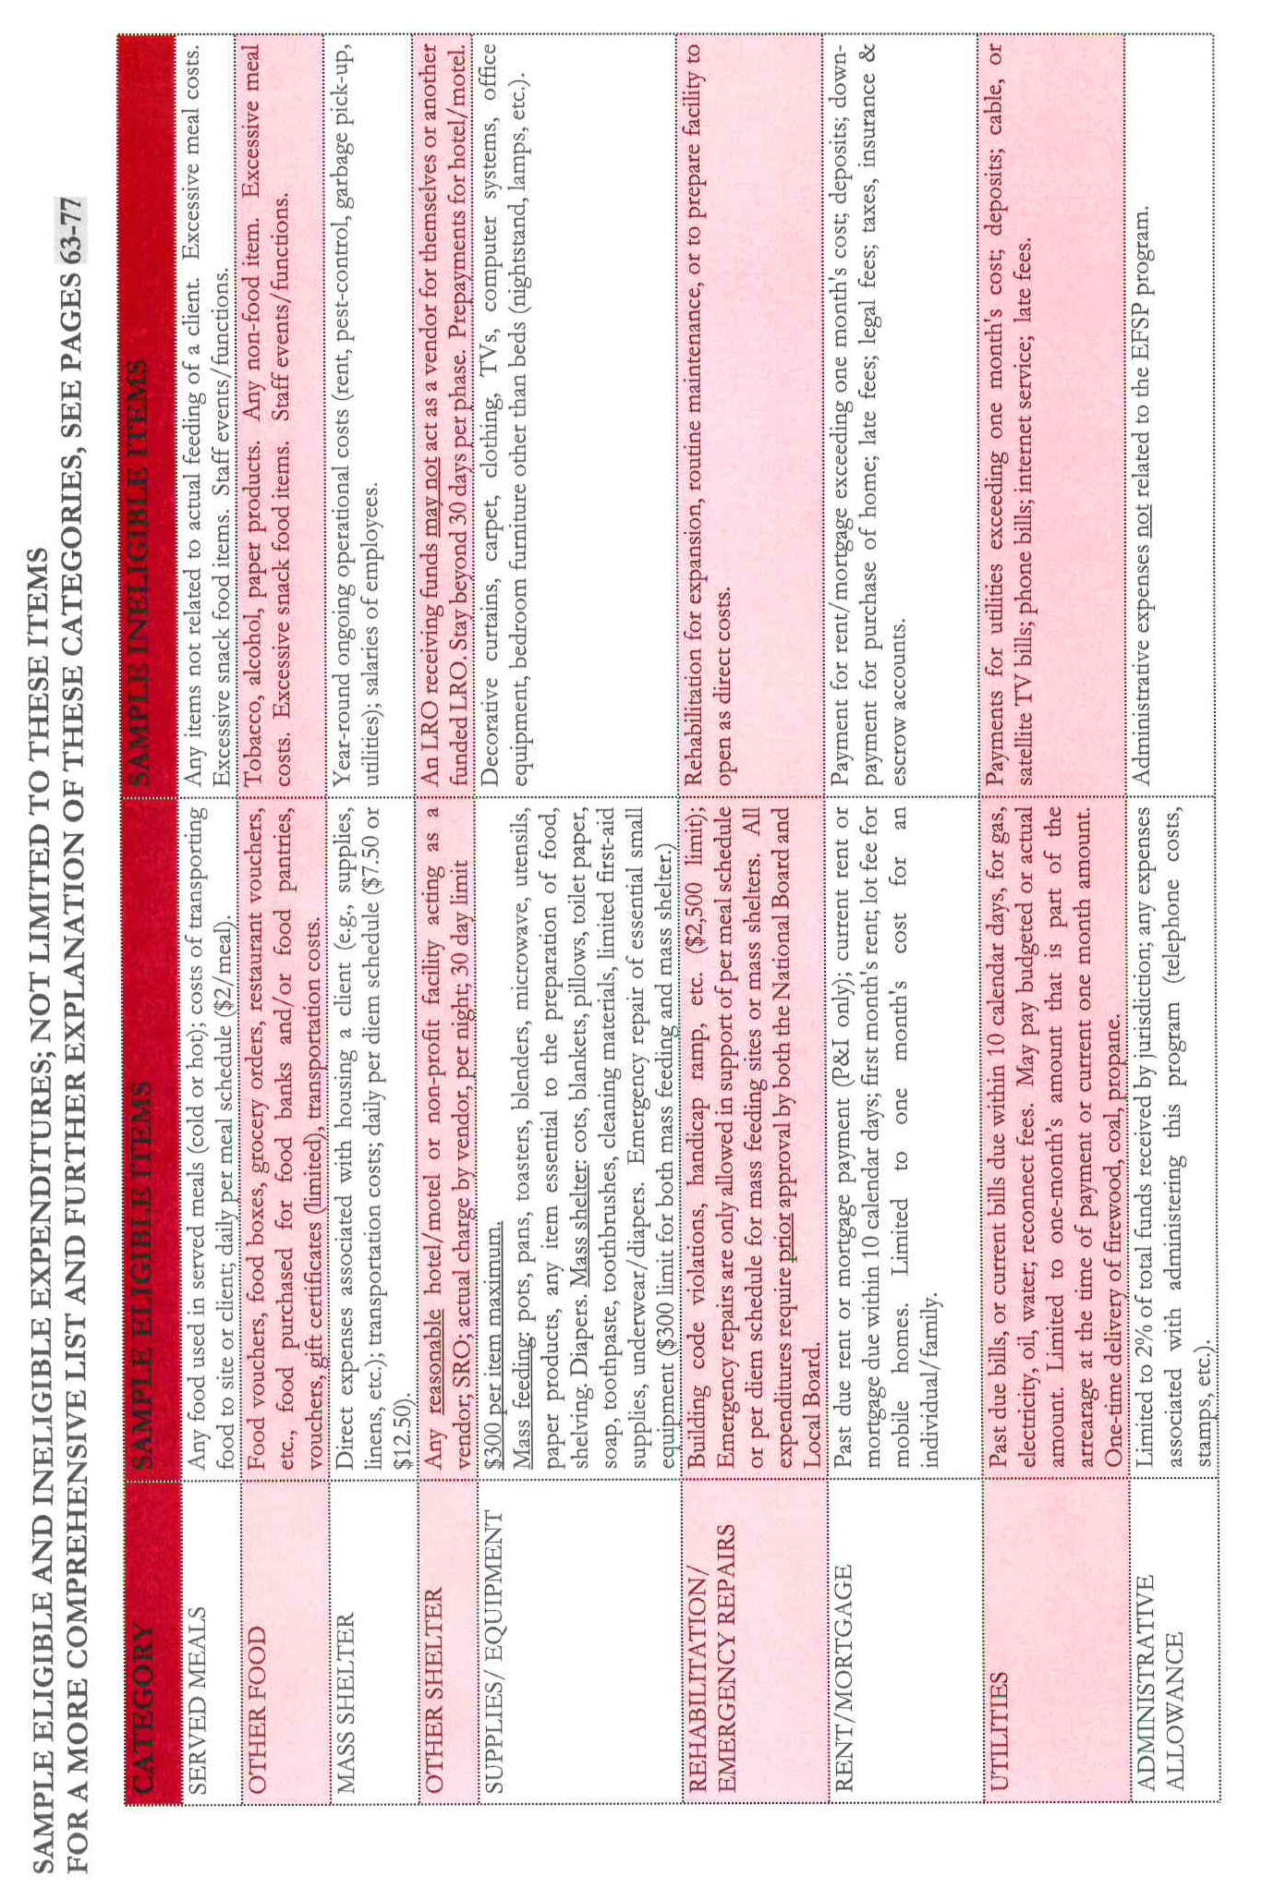
Please be sure to check the Phase 35 Manual.

For more information, visit efsp.unitedway.org.

